

TECHNOLOGY FOR MANAGEMENT
ASSIGNMENT – SEM 2
CLASS – MBA II - ‘B’

SUBMITTED TO:
Dr. MRINMOY ROY
SUBMITTED BY:
HIMANSHU SINGH
MALATESH KUMAR PATIL

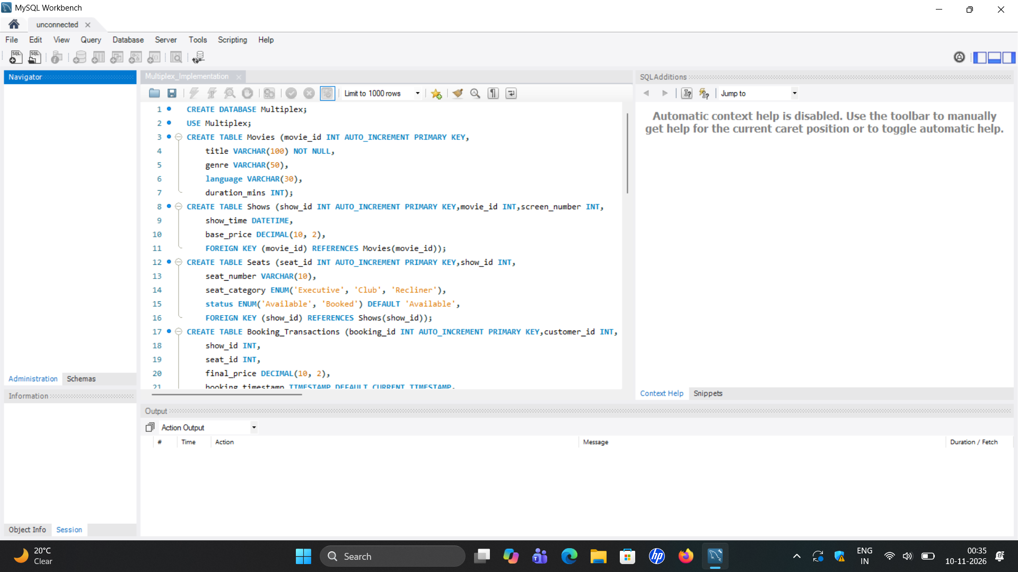

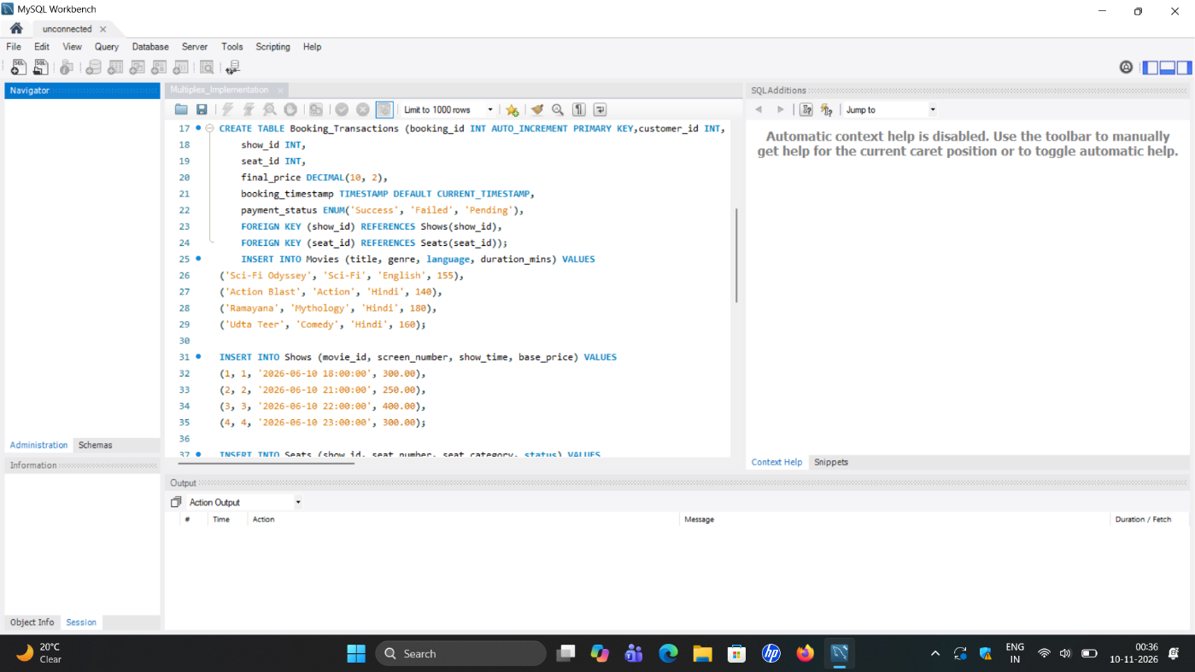

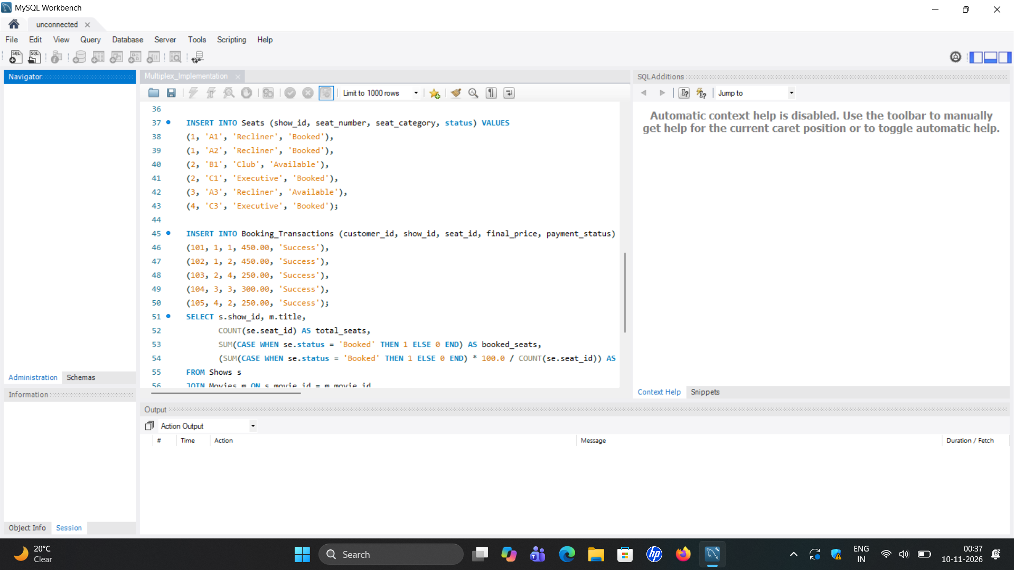

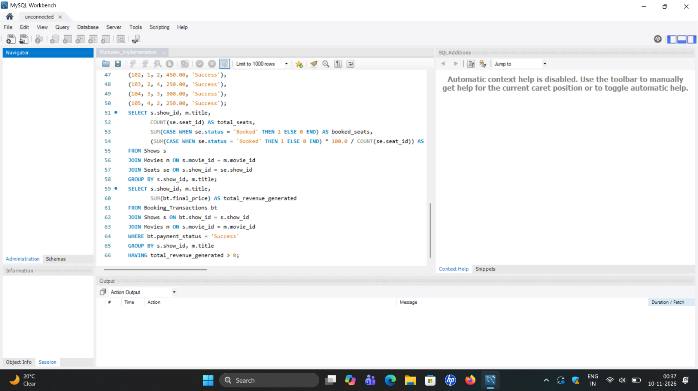

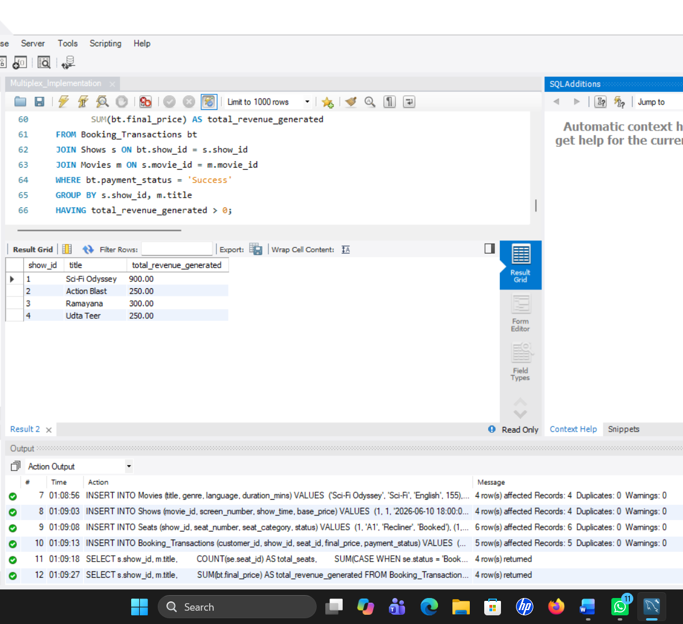

Enterprise Framework Diagram

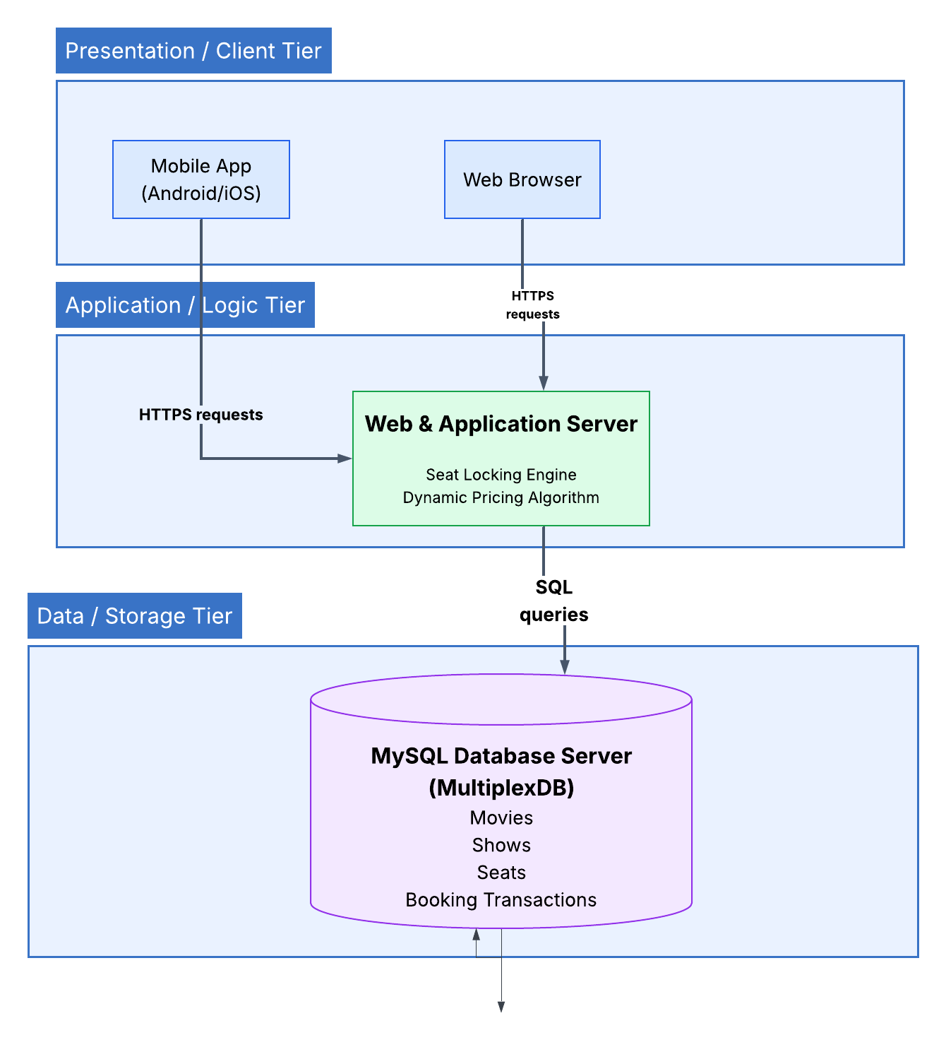

3-Tier Architecture Diagram

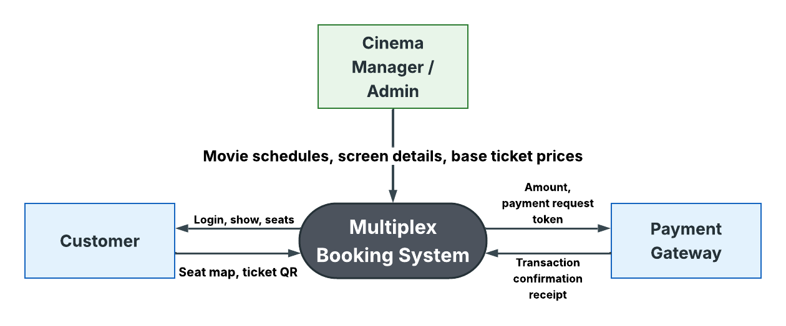

LEVEL-1 DFD Diagram

LEVEL 0 DFD Diagram

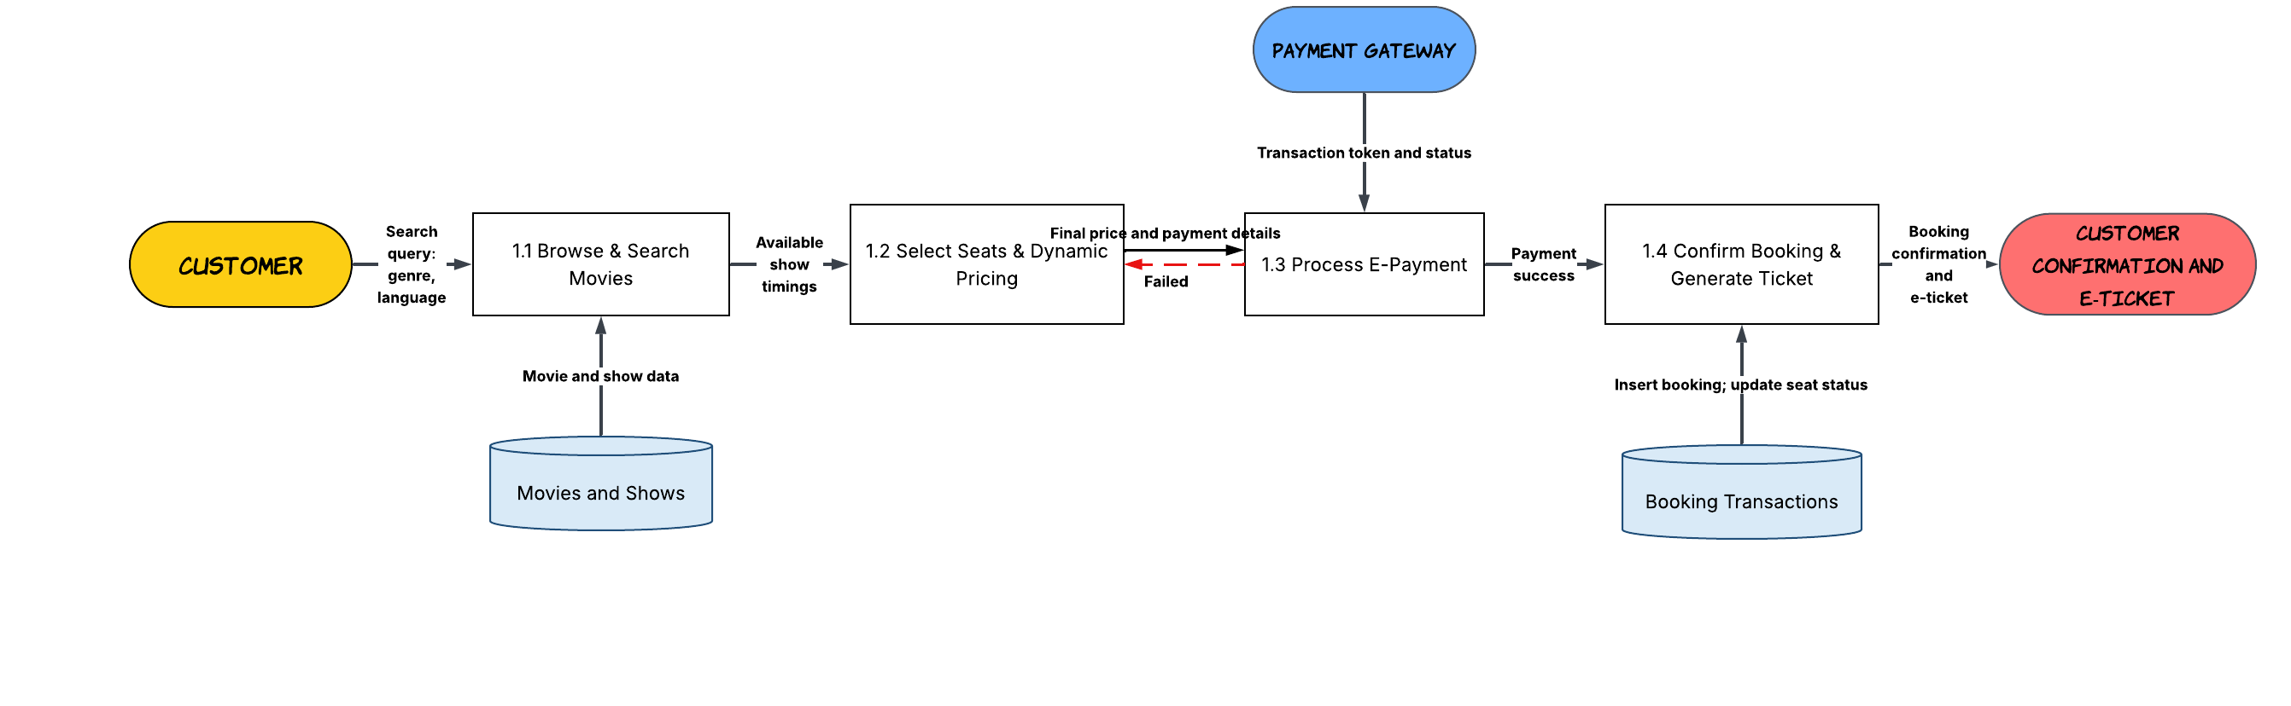

Agile/Iterative SDLC model:
​Why Agile?
Movie booking apps require frequent updates (adding new movie releases every week, tweaking dynamic pricing rules based on demand, and rolling out UI enhancements). The iterative Agile model allows flexible adjustments compared to a rigid Waterfall model.

Technology Adoption Framework (TAM Analysis)

To evaluate user acceptance of the Multiplex Movie Booking & Dynamic Pricing System, the Technology Acceptance Model (TAM) was applied across two primary dimensions: Perceived Usefulness (PU) and Perceived Ease of Use (PEOU).
Technology Acceptance Model

Perceived Usefulness (PU) | Perceived Ease of Use (PEOU)
- Real-Time Seat Allocation | - 3-step quick checkout
- Transparent Pricing Alerts | - Interactive seat map selection
- Instant E-ticket Delivery | - Saved payment tokens

[High User Adoption]

Perceived Usefulness (PU):
- ​Customers experience zero waiting time by bypassing physical box office ticket queues.

- ​Instant access to real-time seat availability maps allows customers to choose preferred viewing angles (Recliner vs. Club vs. Executive).

- ​Automated digital ticket delivery (QR code via SMS/Email) eliminates physical paper ticket handling.

Perceived Ease of Use (PEOU):
- ​Simple 3-step checkout flow:
Select Movie Pick Seats Pay via UPI/Card.

- ​High visual feedback on seat selection
(Green = Available, Red = Booked, Blue = Selected).

- ​One-click payment integration reduces friction and cognitive load for mobile users.

E-Payment Gateway Integration & Workflow
​The system integrates an end-to-end API payment architecture supporting UPI, Net Banking, and Credit/Debit Cards.

Step-by-Step Payment Sequence:
- ​Initiation: The web/mobile app locks selected seats (status = 'Pending') for 5 minutes to prevent race conditions or double-booking.
- ​API Handshake: The system securely forwards the order payload (booking_id, final_price, customer_id) to the Payment Gateway API (e.g., Razorpay / Paytm).

- ​Tokenized Authentication: The user completes 2-Factor Authentication (OTP / UPI PIN) via an encrypted payment gateway modal.

- ​Callback & Verification:
    - On Success: Payment Gateway sends a 200 OK webhook callback with a transaction hash. The database updates Booking_Transactions.payment_status = 'Success' and Seats.status = 'Booked'.

    - On Failure: The database releases the locked seats back to status = 'Available', and updates payment_status = 'Failed'.

IT ETHICS, PRIVACY & SECURITY COMPLIANCE

Data Privacy Compliance Audit
The platform complies with standard data protection regulations (Digital Personal Data Protection Act / GDPR) regarding customer Personally Identifiable Information (PII).

- ​PII Governance: Customer details (Phone numbers, Email IDs, Name) are stored using AES-256 encryption at rest.

- ​Payment Security (PCI-DSS Compliance): The system does not store raw credit/debit card numbers or UPI PINs on internal MySQL servers. All payment handling is offloaded to PCI-DSS certified gateway providers.

- ​Consent & Transparency: Users explicitly consent to transactional SMS/Email notifications during registration. An opt-out mechanism is provided for promotional notifications.

Cybercrime Threat & Risk Mitigation Matrix

Threat/Risk | Vulnerability Vector | Severity | Mitigation Strategy
Bot Seat-Hoarding | Automated scripts locking premium seats to create artificial scarcity | HIGH | Implement Google reCAPTCHA v3 on seat selection and enforce a 5-minute hard timeout on seat holds.
SQL Injection (SQLi) | Malicious inputs in search fields attempting to access or modify database tables | CRITICAL | Use Prepared Statements and Parameterized Queries across all backend application scripts.
Double-Booking Race Condition | Simultaneous transactions claiming the exact same seat at the exact same millisecond | HIGH | Enforce row-level database locking (SELECT … FOR UPDATE) during seat transaction commits.
Data Sniffing / Man-in-the-Middle | Intercepting ticket data or payment credentials over public Wi-Fi | HIGH | Mandatory TLS 1.3/ HTTPS encryption across all API endpoints and web socket.

THANK YOU

